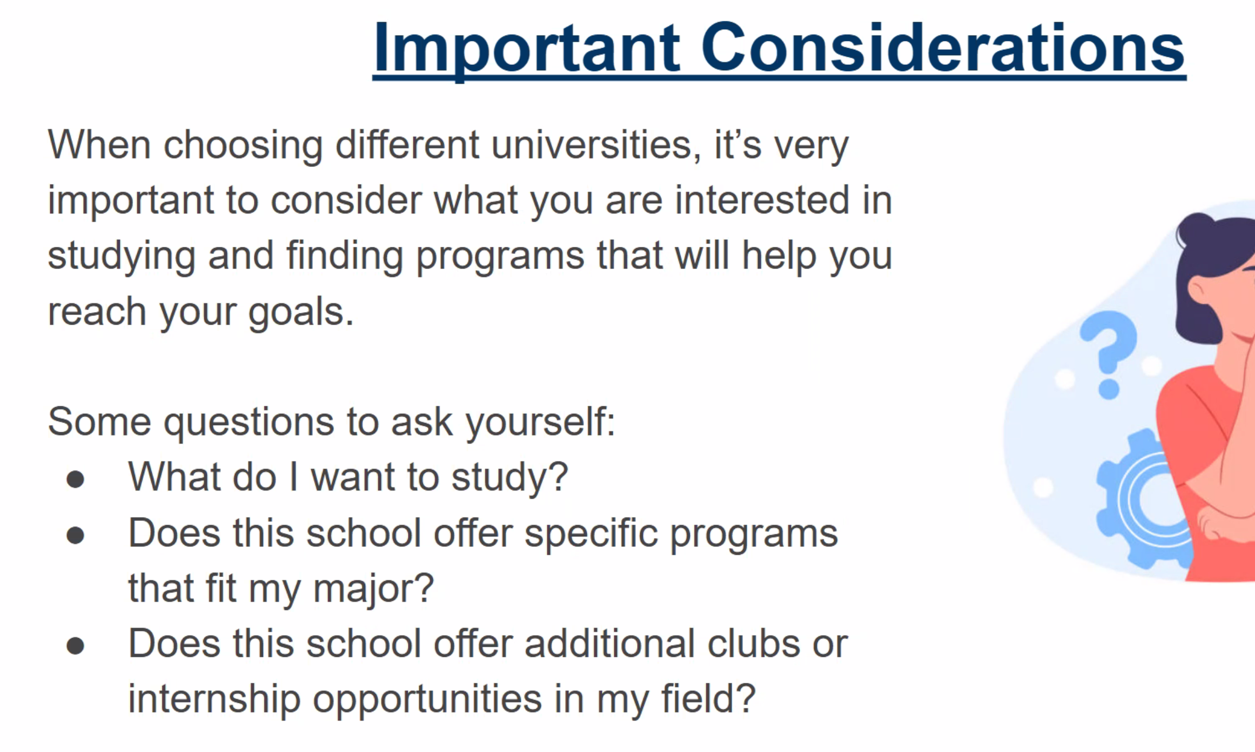
deciding

field & major

minor: should complement major

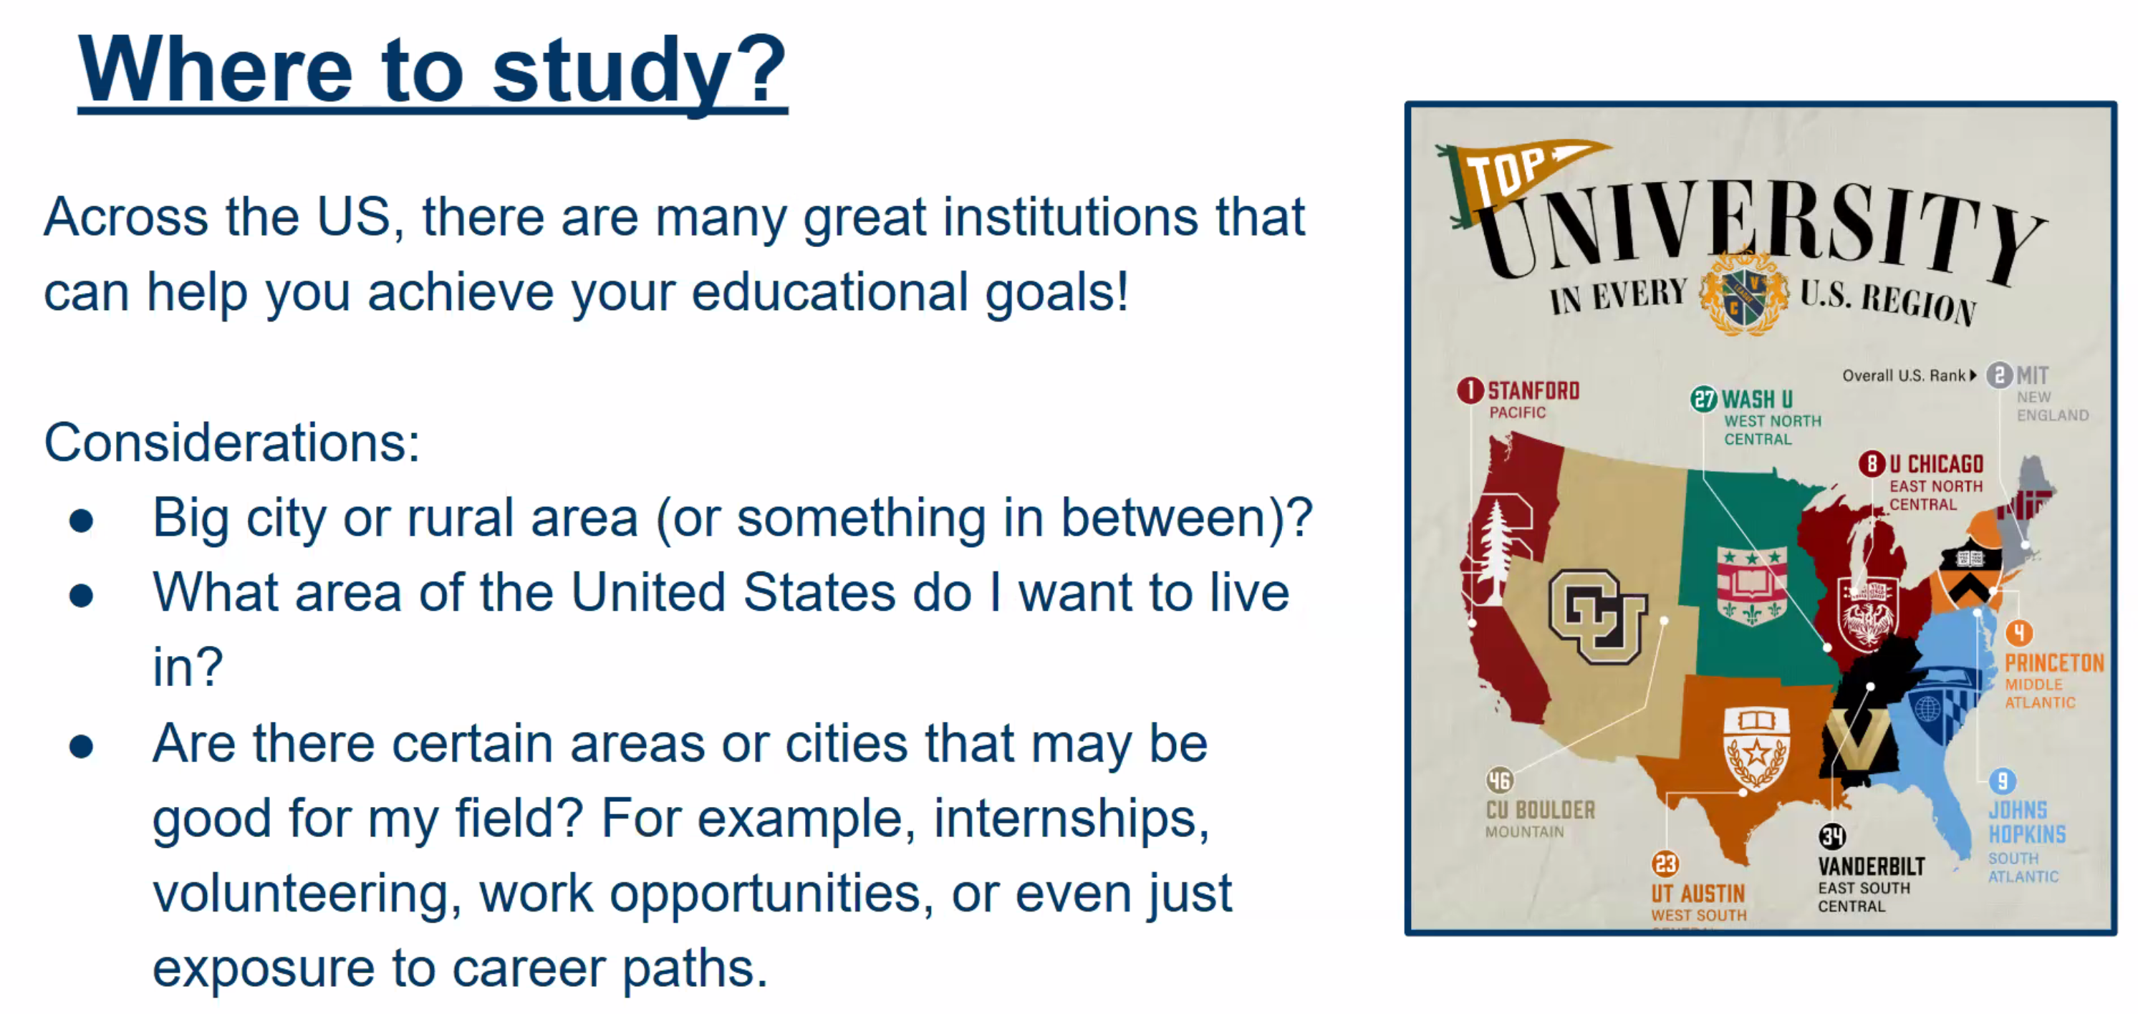

Weather?
some states excell at subjects

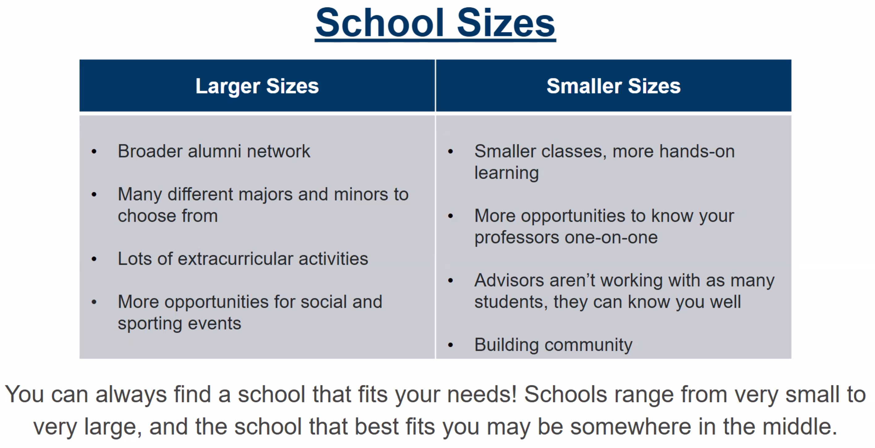

Consider class sizes, personalization, social network as well

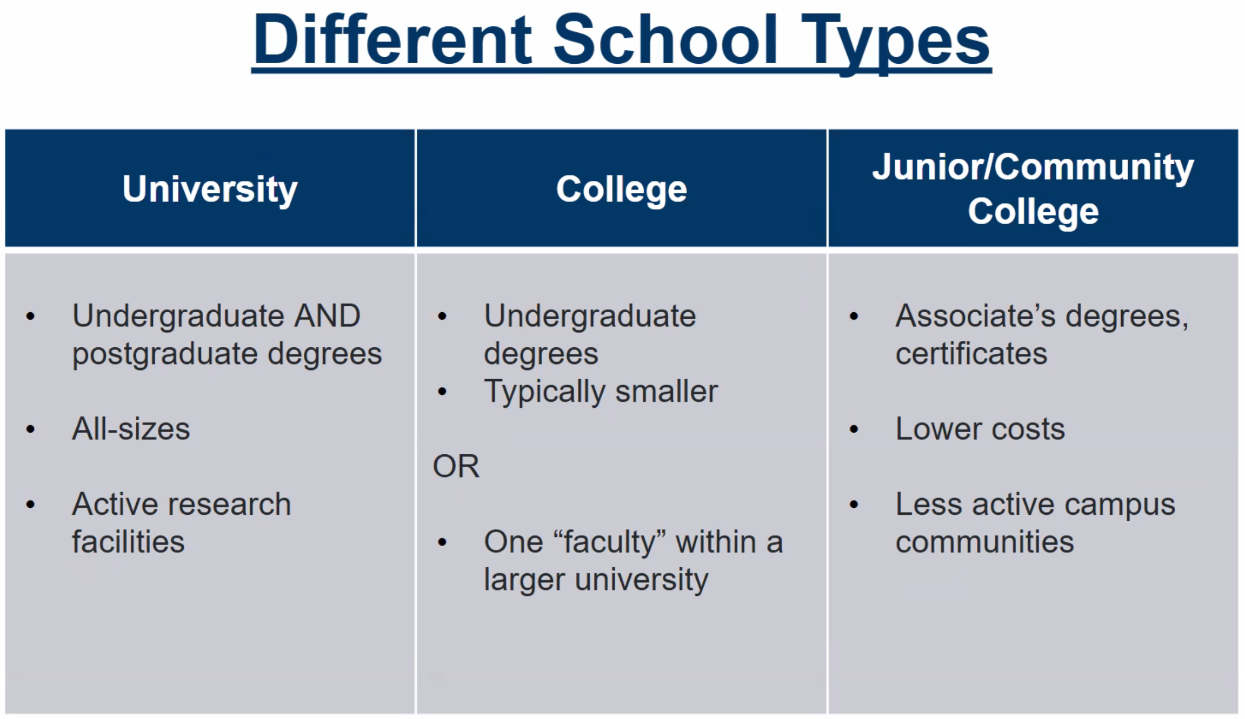

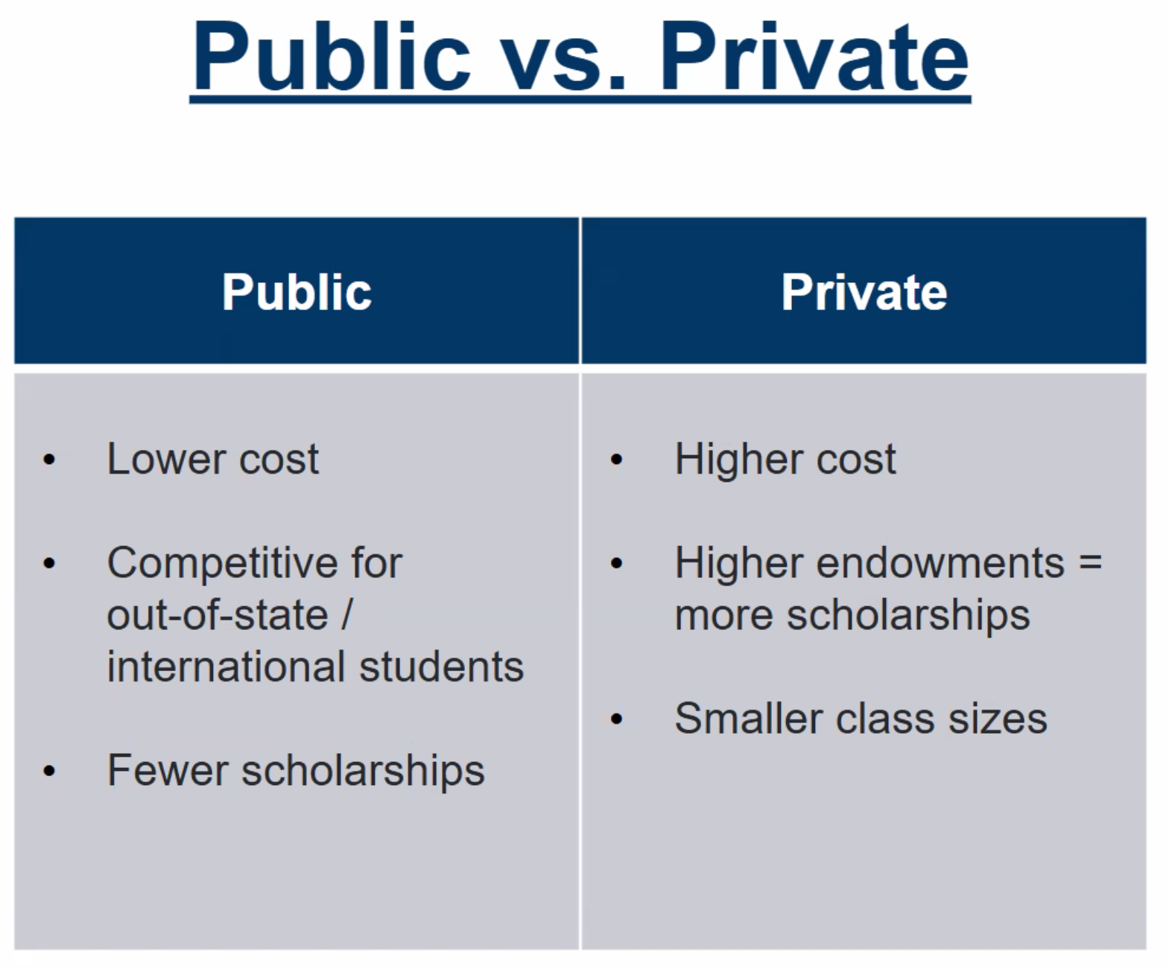
Private universities have more options for scholarships and financial support

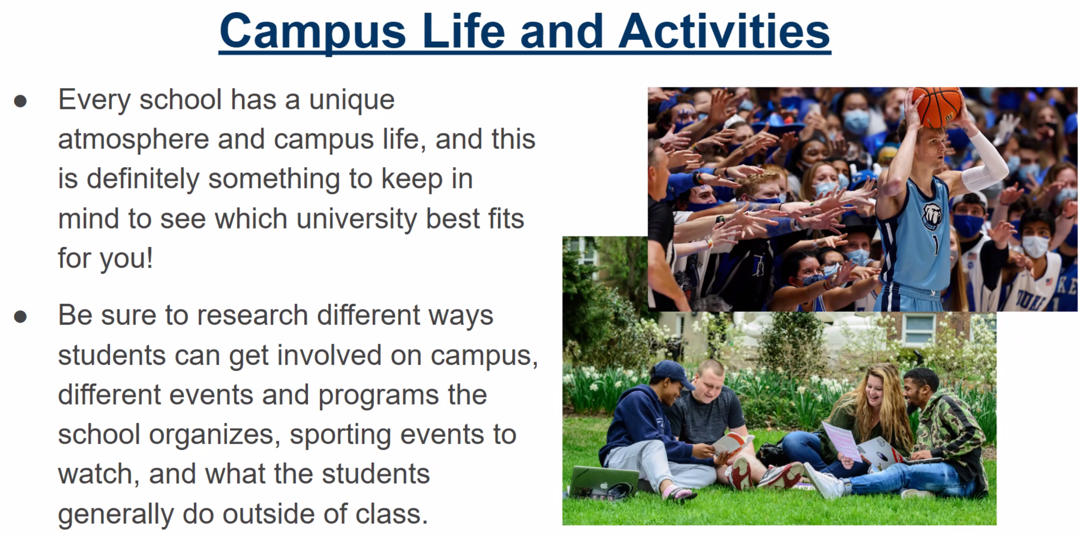

Research websites for student life

Always consider requirements FOR INTERNATIONAL STUDENTS!

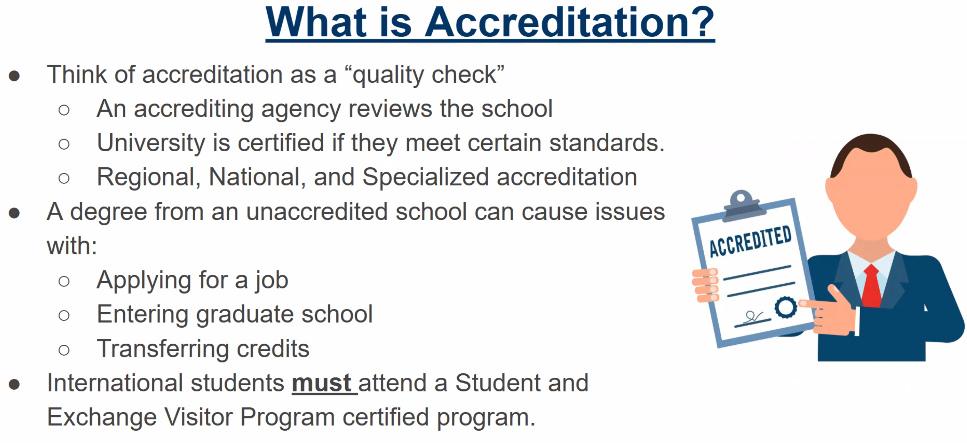

Accreditation is important for work requirements later down the line

not all universities offer oppurtunities international



Costs should consider accomodation as well



